MENTAL HEALTH MANAGEMENT SYSTEM

CHAPTER FOUR: SYSTEM DESIGN AND IMPLEMENTATION

4.1 Objective of Design
The Mental Health Management System is designed to provide a comprehensive platform for managing mental health services. The primary objectives of the design include:

- User-Centric Approach: Creating a seamless experience for patients seeking mental health support
- Therapist Management: Providing tools for therapists to manage their practice efficiently
- Secure Communication: Establishing secure channels for patient-therapist communication
- Appointment Management: Streamlining the process of scheduling and managing appointments
- Data Security: Ensuring sensitive medical data is protected according to healthcare standards

The system aims to bridge the gap between patients and mental health professionals, making mental healthcare more accessible while maintaining high standards of privacy and security.

4.2 System Architecture in Terms of Tiers
The Mental Health Management System follows a modern three-tier architecture pattern, enhanced with client-side rendering capabilities.

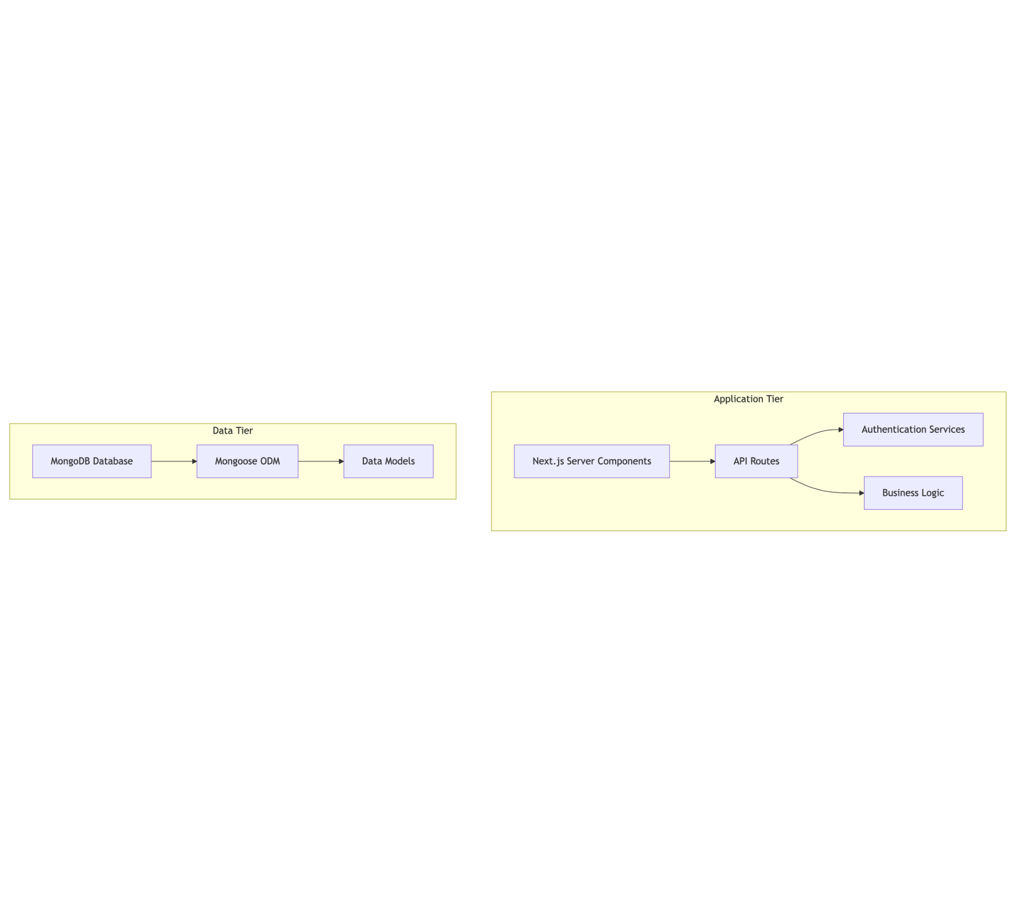
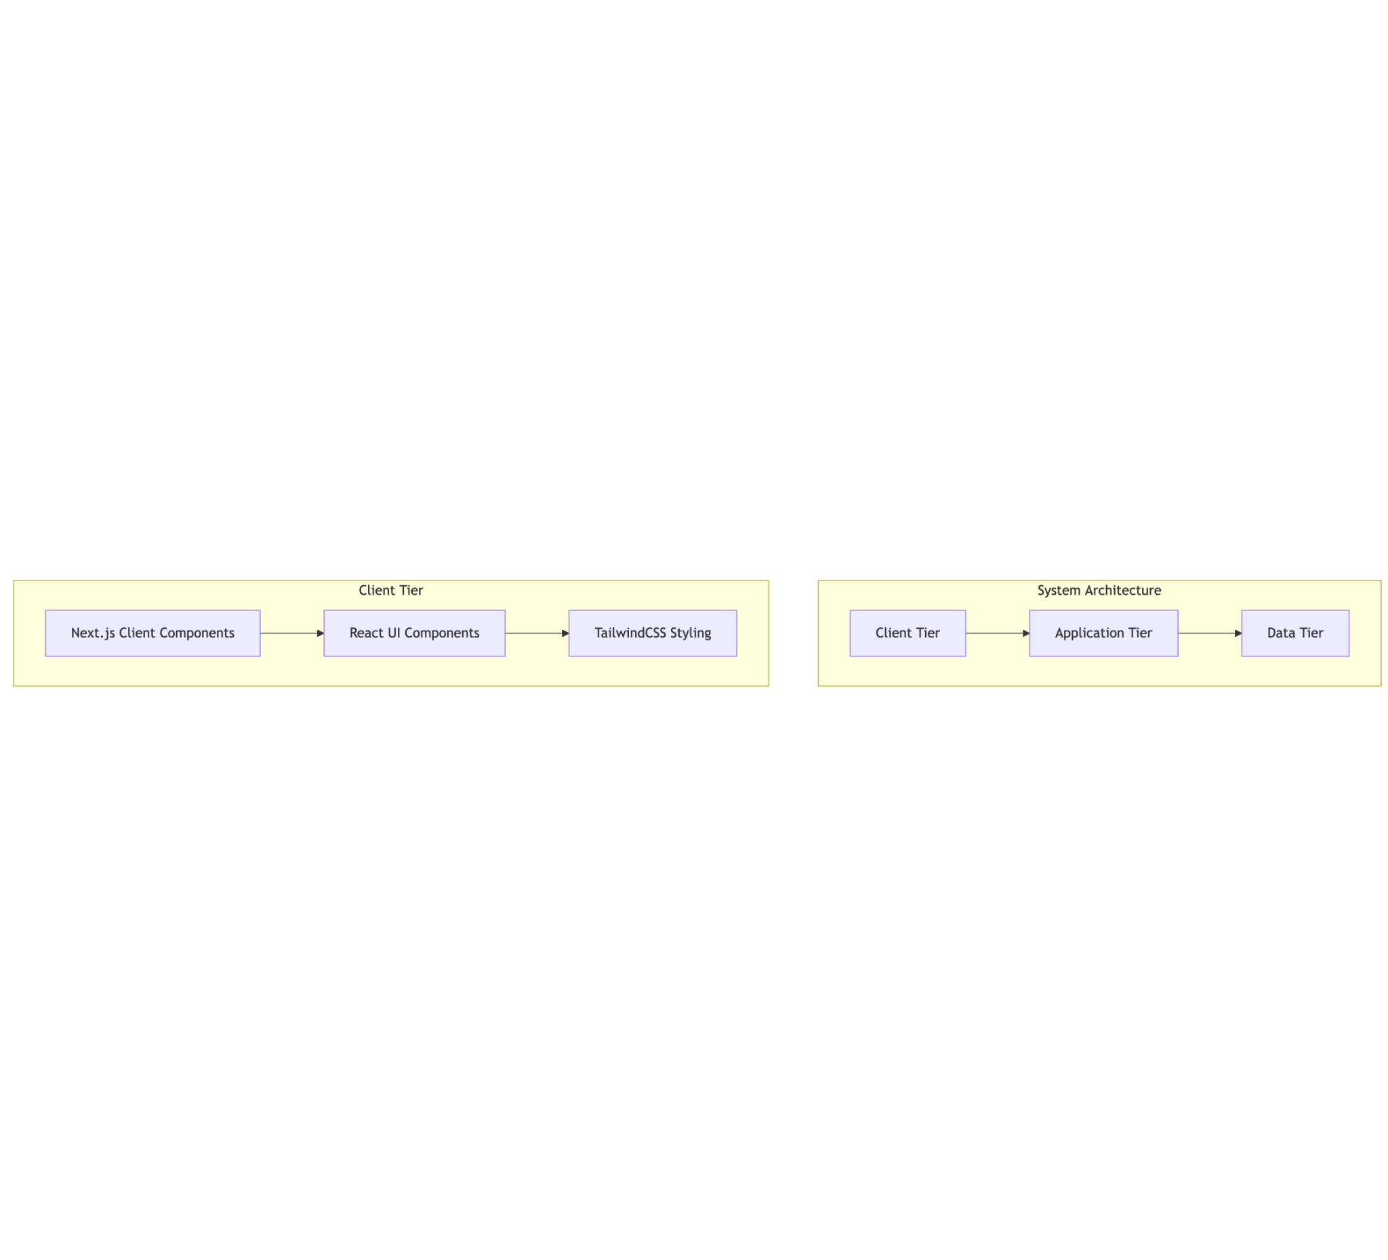
Figure 1: System Architecture

Client Tier:

- Utilizes Next.js client components for interactive UI elements
- Implements responsive design with TailwindCSS
- Handles client-side form validation and state management

Application Tier:

- Leverages Next.js API routes for server-side operations
- Implements business logic for appointments, messaging, and user management
- Provides authentication services using NextAuth.js
- Processes data between the client and data tiers

Data Tier:

- Uses MongoDB as the NoSQL database for flexible data storage
- Implements Mongoose ODM for data modeling and validation
- Maintains data integrity and relationships between entities

This architecture (Figure 1) provides several advantages including separation of concerns, scalability, and maintainability.

4.3 Choice of Programming Environment
The system is built using the following programming environment:

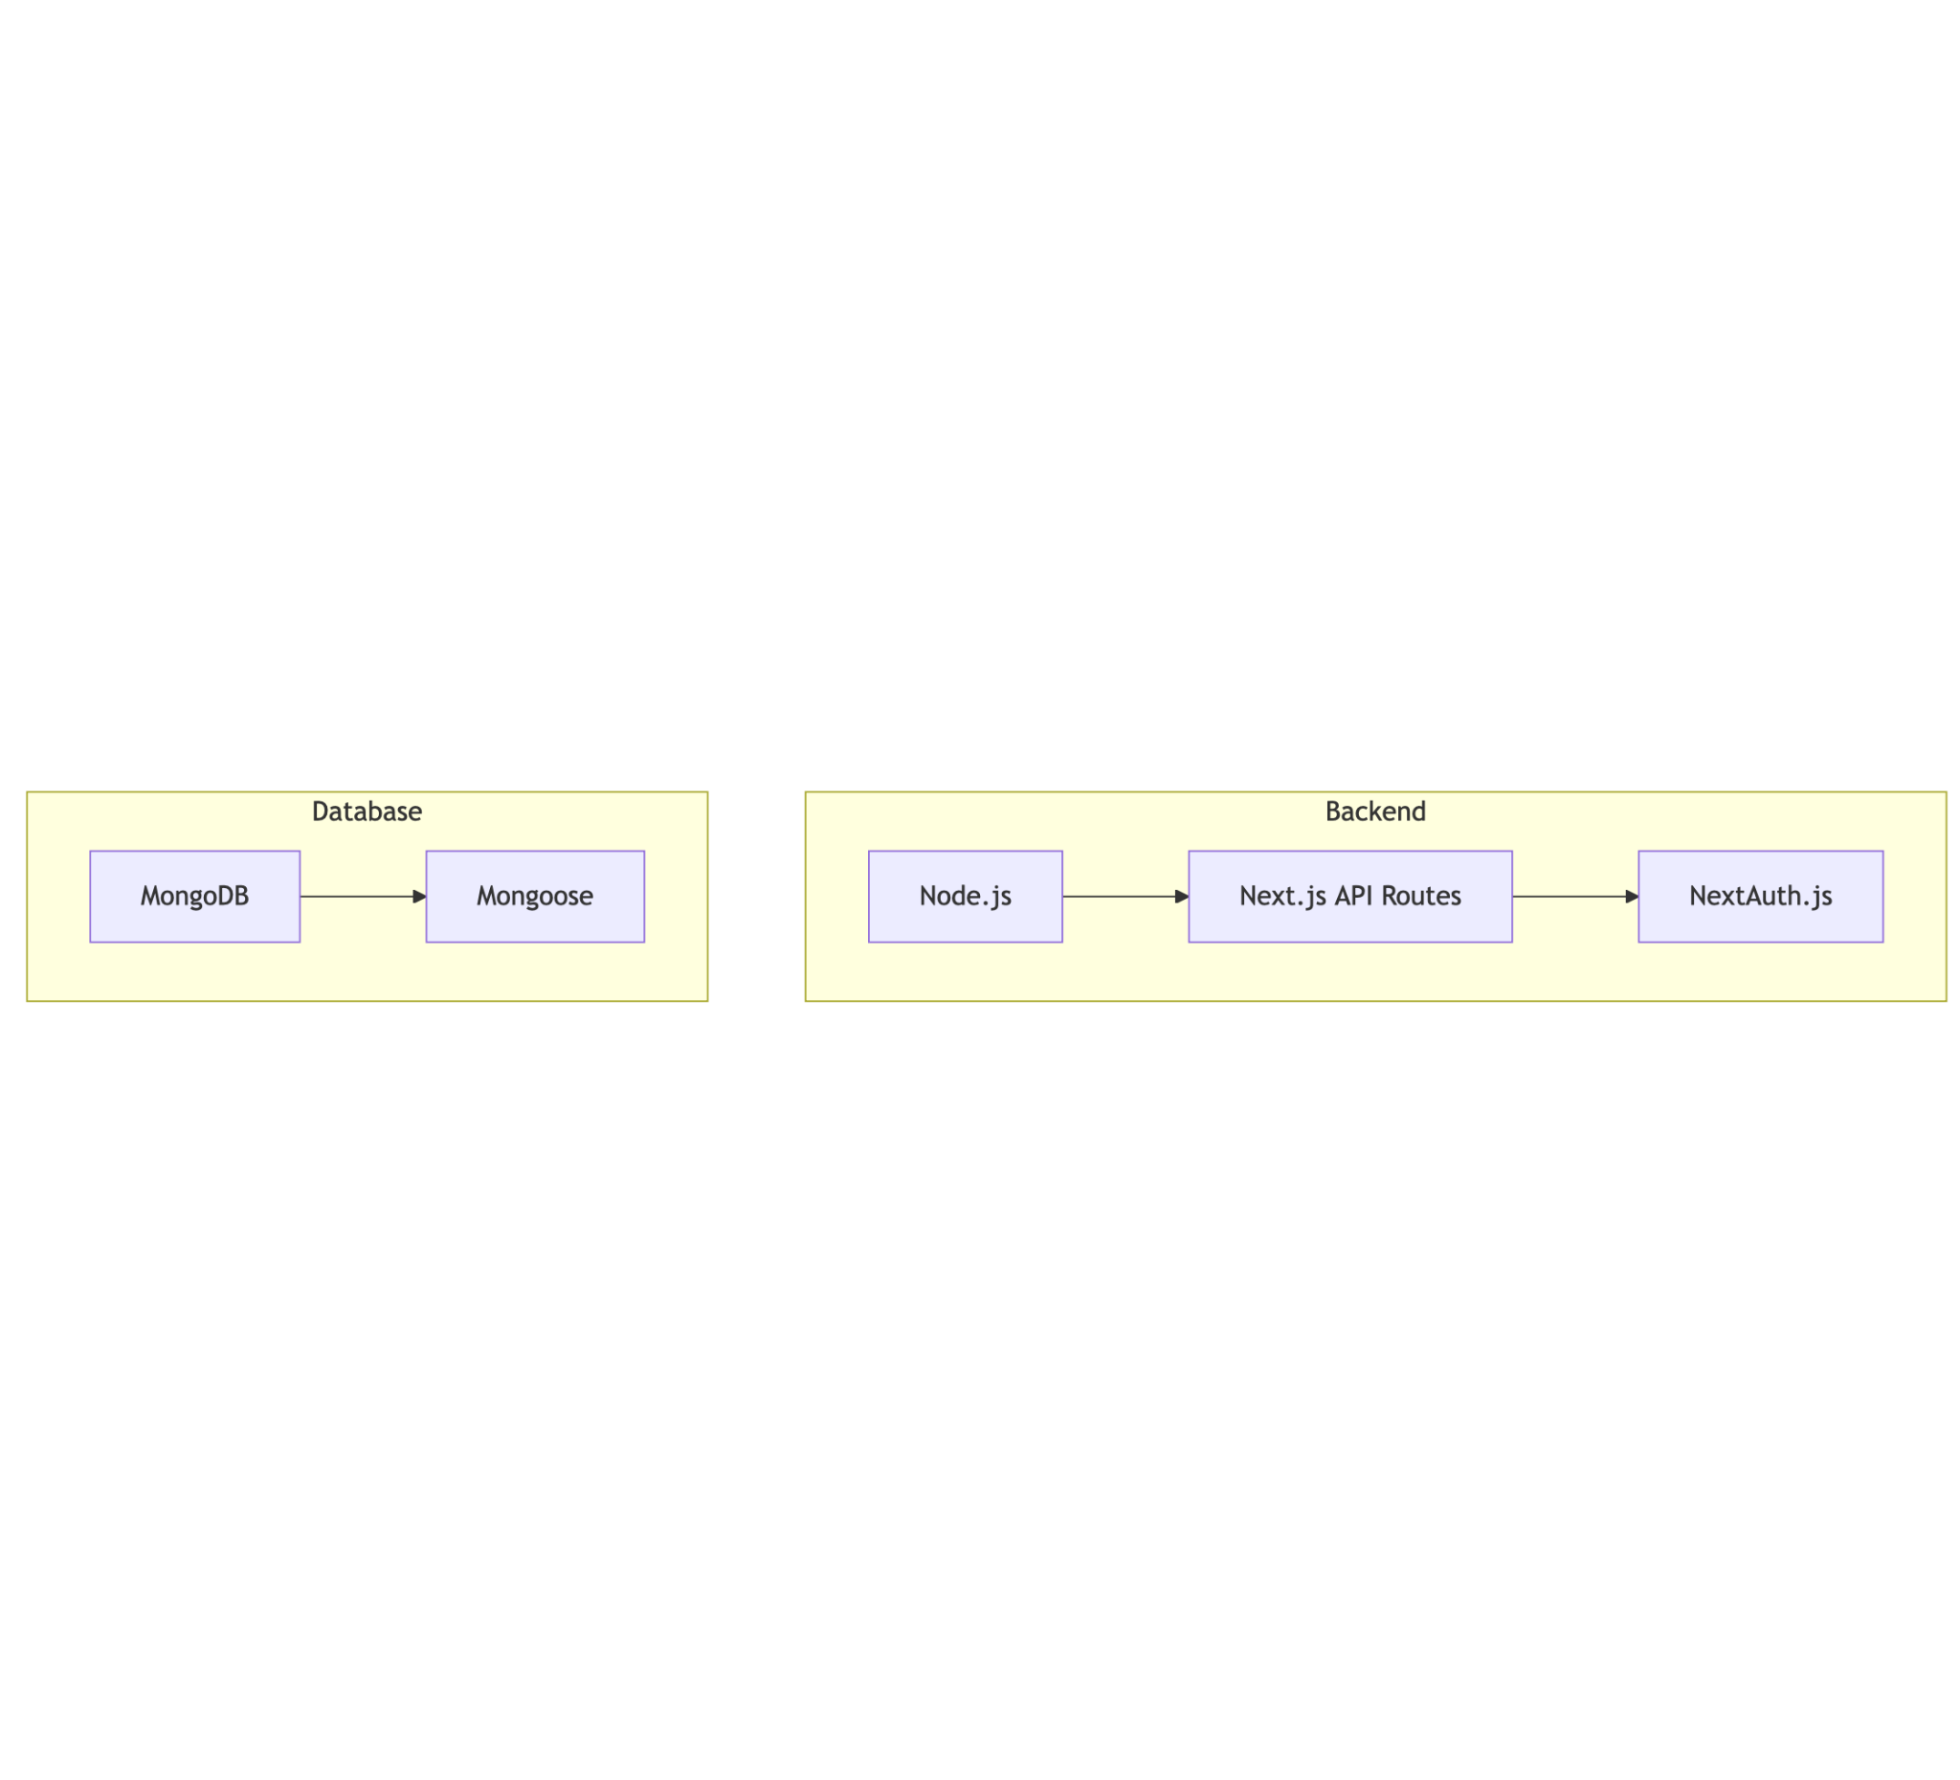
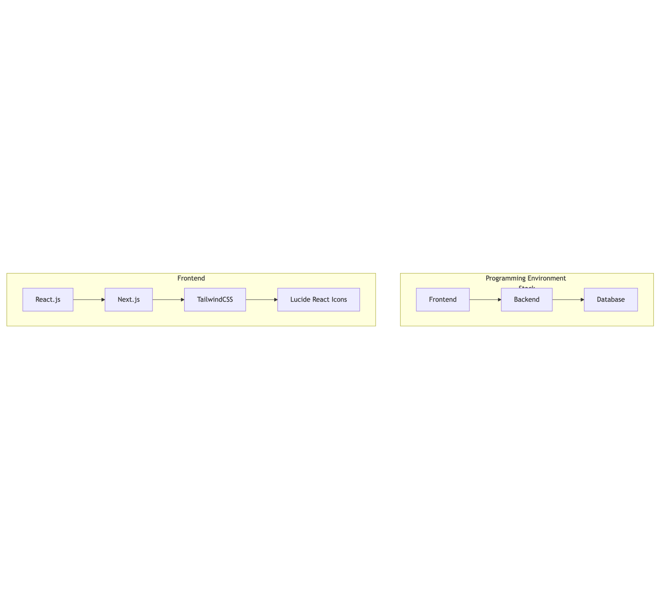
Figure 2: Programming Environment Stack

Frontend:

- React.js: A JavaScript library for building user interfaces
- Next.js: A React framework providing server-side rendering, routing, and API functionality
- TailwindCSS: A utility-first CSS framework for rapidly building custom designs
- Lucide React: A collection of simply beautiful open-source icons

Backend:

- Node.js: JavaScript runtime for server-side logic
- Next.js API Routes: Server-side API endpoints within the Next.js framework
- NextAuth.js: Authentication library for Next.js applications

Database:

- MongoDB: A NoSQL database providing flexibility for evolving data schemas
- Mongoose: An Object Data Modeling (ODM) library for MongoDB and Node.js

This stack (Figure 2) was chosen for its modern approach to web development, offering excellent developer experience, performance, and scalability.

4.4 Database Structure
The database follows a document-oriented structure typical of MongoDB, with clear relationships between collections.

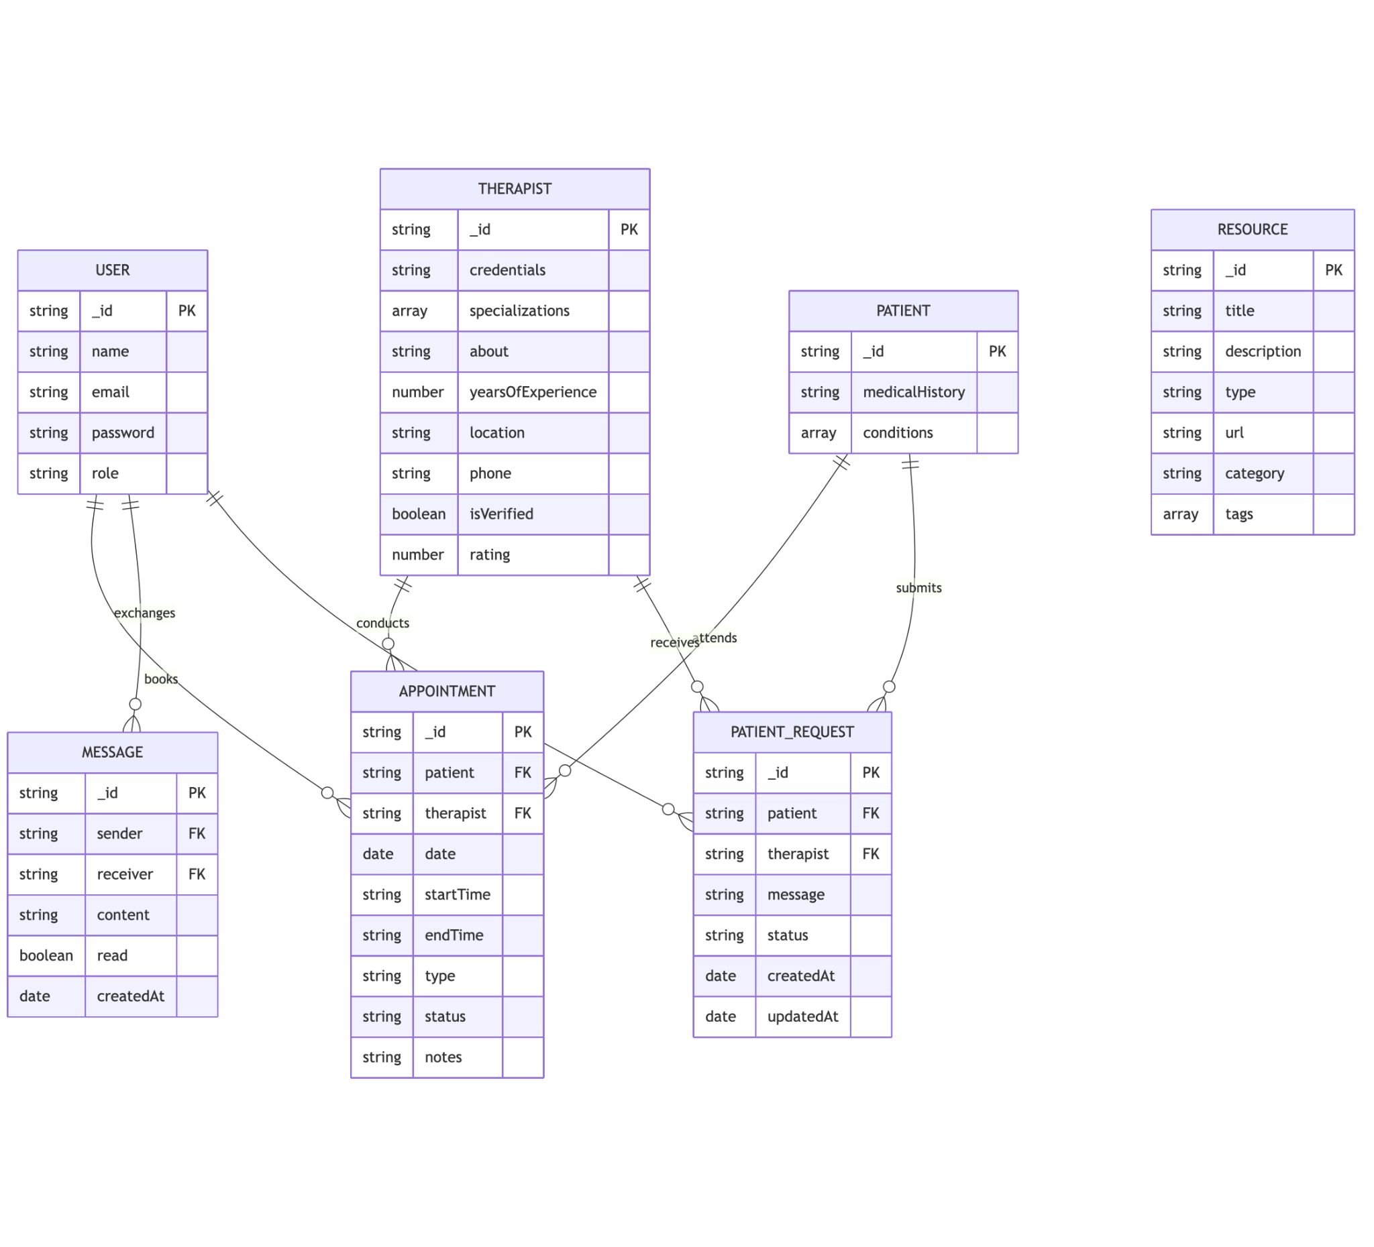
Figure 3: Entity Relationship Diagram

The database structure demonstrates the relationships between users (both patients and therapists) and their associated data, including appointments, messages, and patient requests.

4.5 Database Table Definition
Below are the detailed definitions of the main collections in our MongoDB database:

1. User Collection

Field | Type | Description
_id | ObjectId | Unique identifier
name | String | User's full name
email | String | User's email address (unique)
password | String | Hashed password
role | String | User type: "user", "patient", "therapist", "admin"

2. Therapist Collection

Field | Type | Description
_id | ObjectId | References User collection
credentials | String | Professional credentials
specializations | [String] | Areas of expertise
licenseNumber | String | Professional license identifier
isVerified | Boolean | Account verification status
about | String | Professional bio
yearsOfExperience | Number | Years of practice
rating | Number | Average rating from patients
location | String | Practice location
phone | String | Contact phone number
availableSlots | [Object] | Available appointment slots

3. Patient Collection

Field | Type | Description
_id | ObjectId | References User collection
medicalHistory | String | Brief medical background
conditions | [String] | List of conditions

4. Appointment Collection

Field | Type | Description
_id | ObjectId | Unique identifier
patient | ObjectId | References User collection
therapist | ObjectId | References User collection
date | Date | Appointment date
startTime | String | Start time
endTime | String | End time
type | String | "initial", "follow-up", or "emergency"
status | String | "scheduled", "completed", "canceled", or "no-show"
notes | String | Additional information
createdAt | Date | Creation timestamp

5. PatientRequest Collection

Field | Type | Description
_id | ObjectId | Unique identifier
patient | ObjectId | References User collection
therapist | ObjectId | References User collection
message | String | Request message
status | String | "pending", "approved", or "rejected"
createdAt | Date | Creation timestamp
updatedAt | Date | Last update timestamp

6. Message Collection

Field | Type | Description
_id | ObjectId | Unique identifier
sender | ObjectId | References User collection
receiver | ObjectId | References User collection
content | String | Message content
read | Boolean | Read status
createdAt | Date | Creation timestamp

4.6 Input and Output Screen Format
The system features a variety of input and output screens designed for intuitive user interaction. Key screens include:

- Authentication Screen (Figure 7)

  - User login and registration
  - Role selection (patient or therapist)

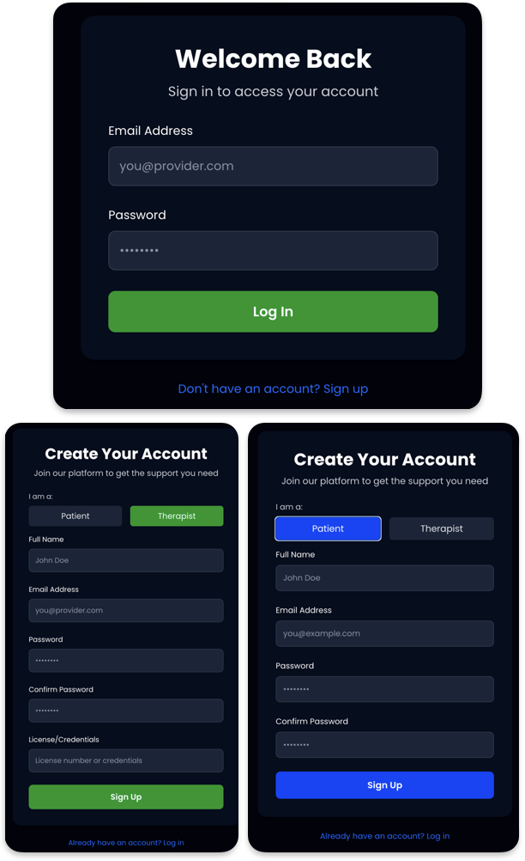

Figure 7: Authentication Screen

- Dashboard Screens (Figure 8)

  - Patient dashboard with upcoming appointments, messages, and resources
  - Therapist dashboard with scheduled appointments, patient requests, and messaging

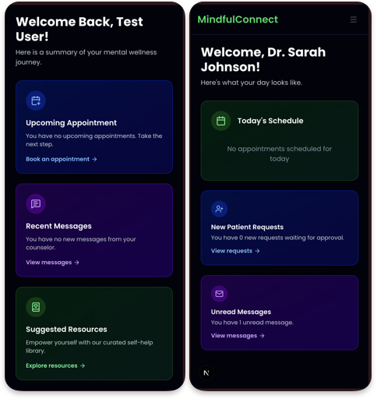
Figure 8: Dashboard Screen

- Profile Management (Figure 9)

  - User profile editing
  - Therapist specialization and credential management

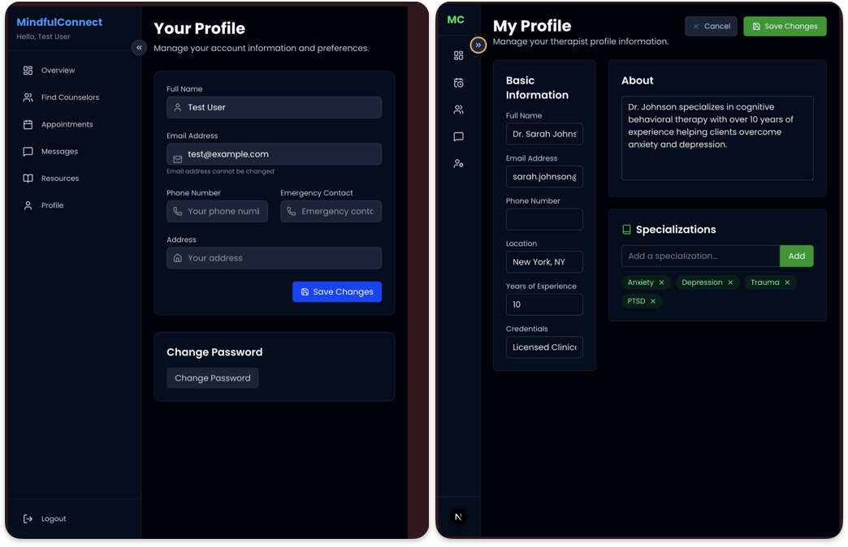
Figure 9: Profile Management Screen

- Appointment Management (Figure 10)

  - Appointment scheduling interface
  - Calendar view
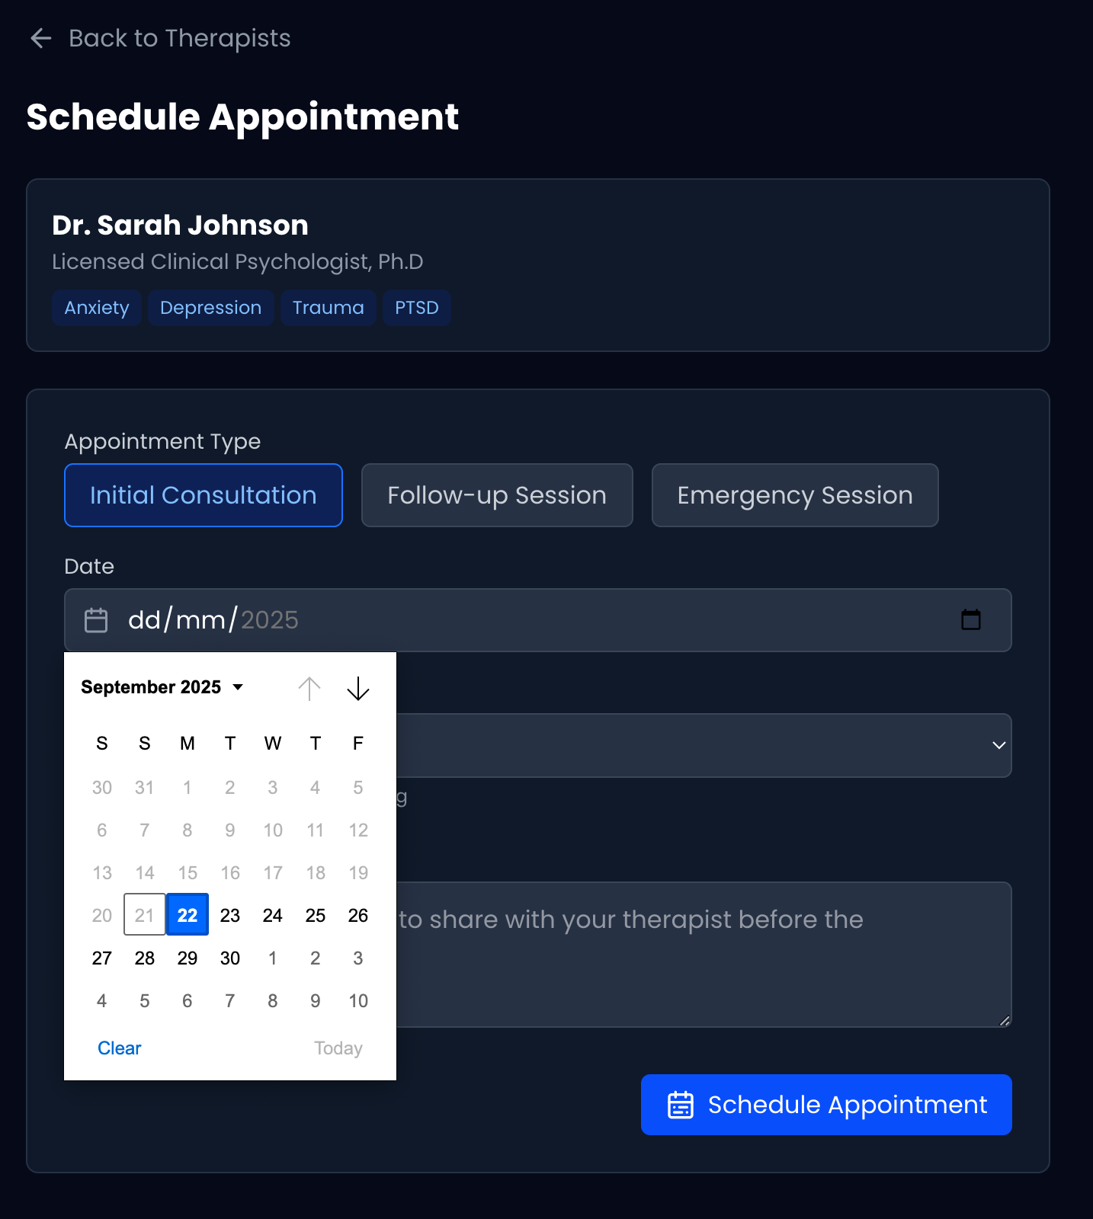

Figure 10: Appointment Management Screen

- Messaging Interface (Figure 11)

  - Chat-style messaging between patients and therapists

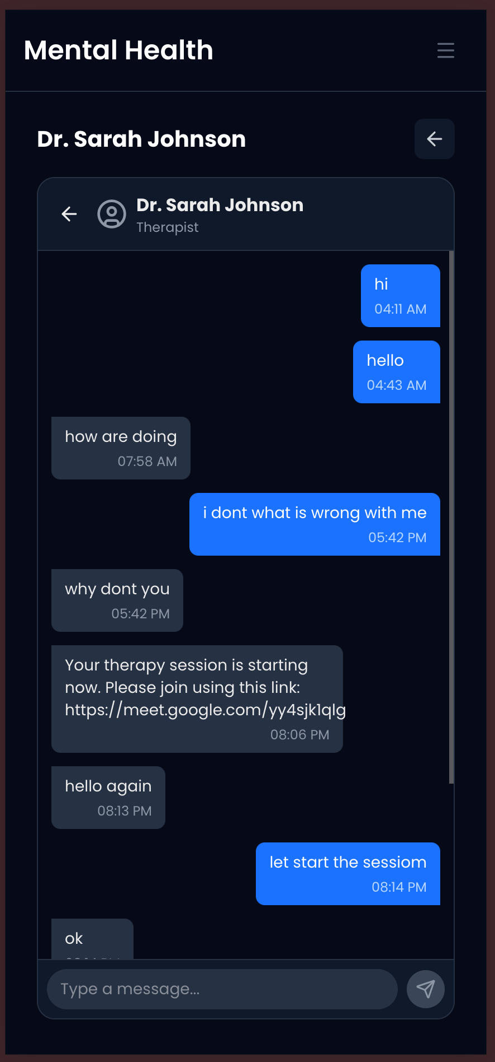
Figure 11: Messaging Screen

The UI is built with responsive design principles, ensuring functionality across desktop and mobile devices, with consistent styling using TailwindCSS. Each screen has been designed with user experience as a priority, following modern web design patterns and accessibility guidelines.

4.7 Program Algorithm
The core algorithms in the system handle various functionalities. Below is a pseudocode representation of the appointment scheduling algorithm:

function scheduleAppointment(patientId, therapistId, date, startTime, appointmentType, notes):

// Input validation

if any required field is empty:

return error "All required fields must be filled"

// Calculate end time (1 hour after start time)

endTime = startTime + 1 hour

// Check if the therapist is available at the requested time

existingAppointments = database.query(

collection: "appointments",

query: {

therapist: therapistId,

date: date,

$or: [

{ startTime: { $lt: endTime, $gte: startTime } },

{ endTime: { $gt: startTime, $lte: endTime } }

]

}

)

if existingAppointments.count > 0:

return error "Therapist is not available at the selected time"

// Create new appointment

appointment = {

patient: patientId,

therapist: therapistId,

date: date,

startTime: startTime,

endTime: endTime,

type: appointmentType,

status: "scheduled",

notes: notes,

createdAt: current_timestamp

}

// Save to database

result = database.insert(collection: "appointments", document: appointment)

// Send notifications

notify(patientId, "Appointment scheduled successfully")

notify(therapistId, "New appointment scheduled")

return success with appointment details

4.8 Program Flowcharts
The following flowcharts illustrate key processes within the system:

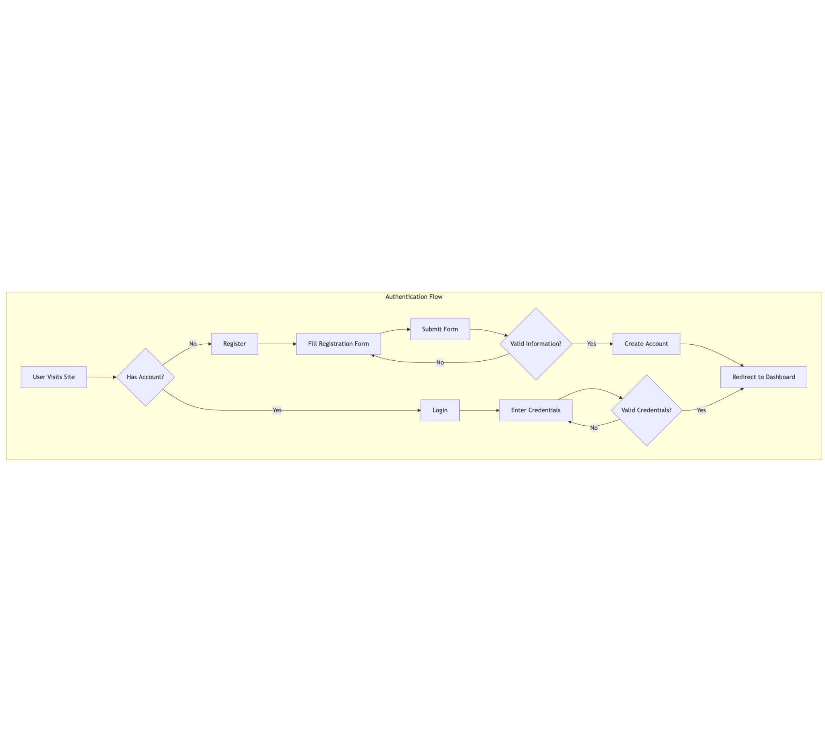
Figure 4: Authentication Flow

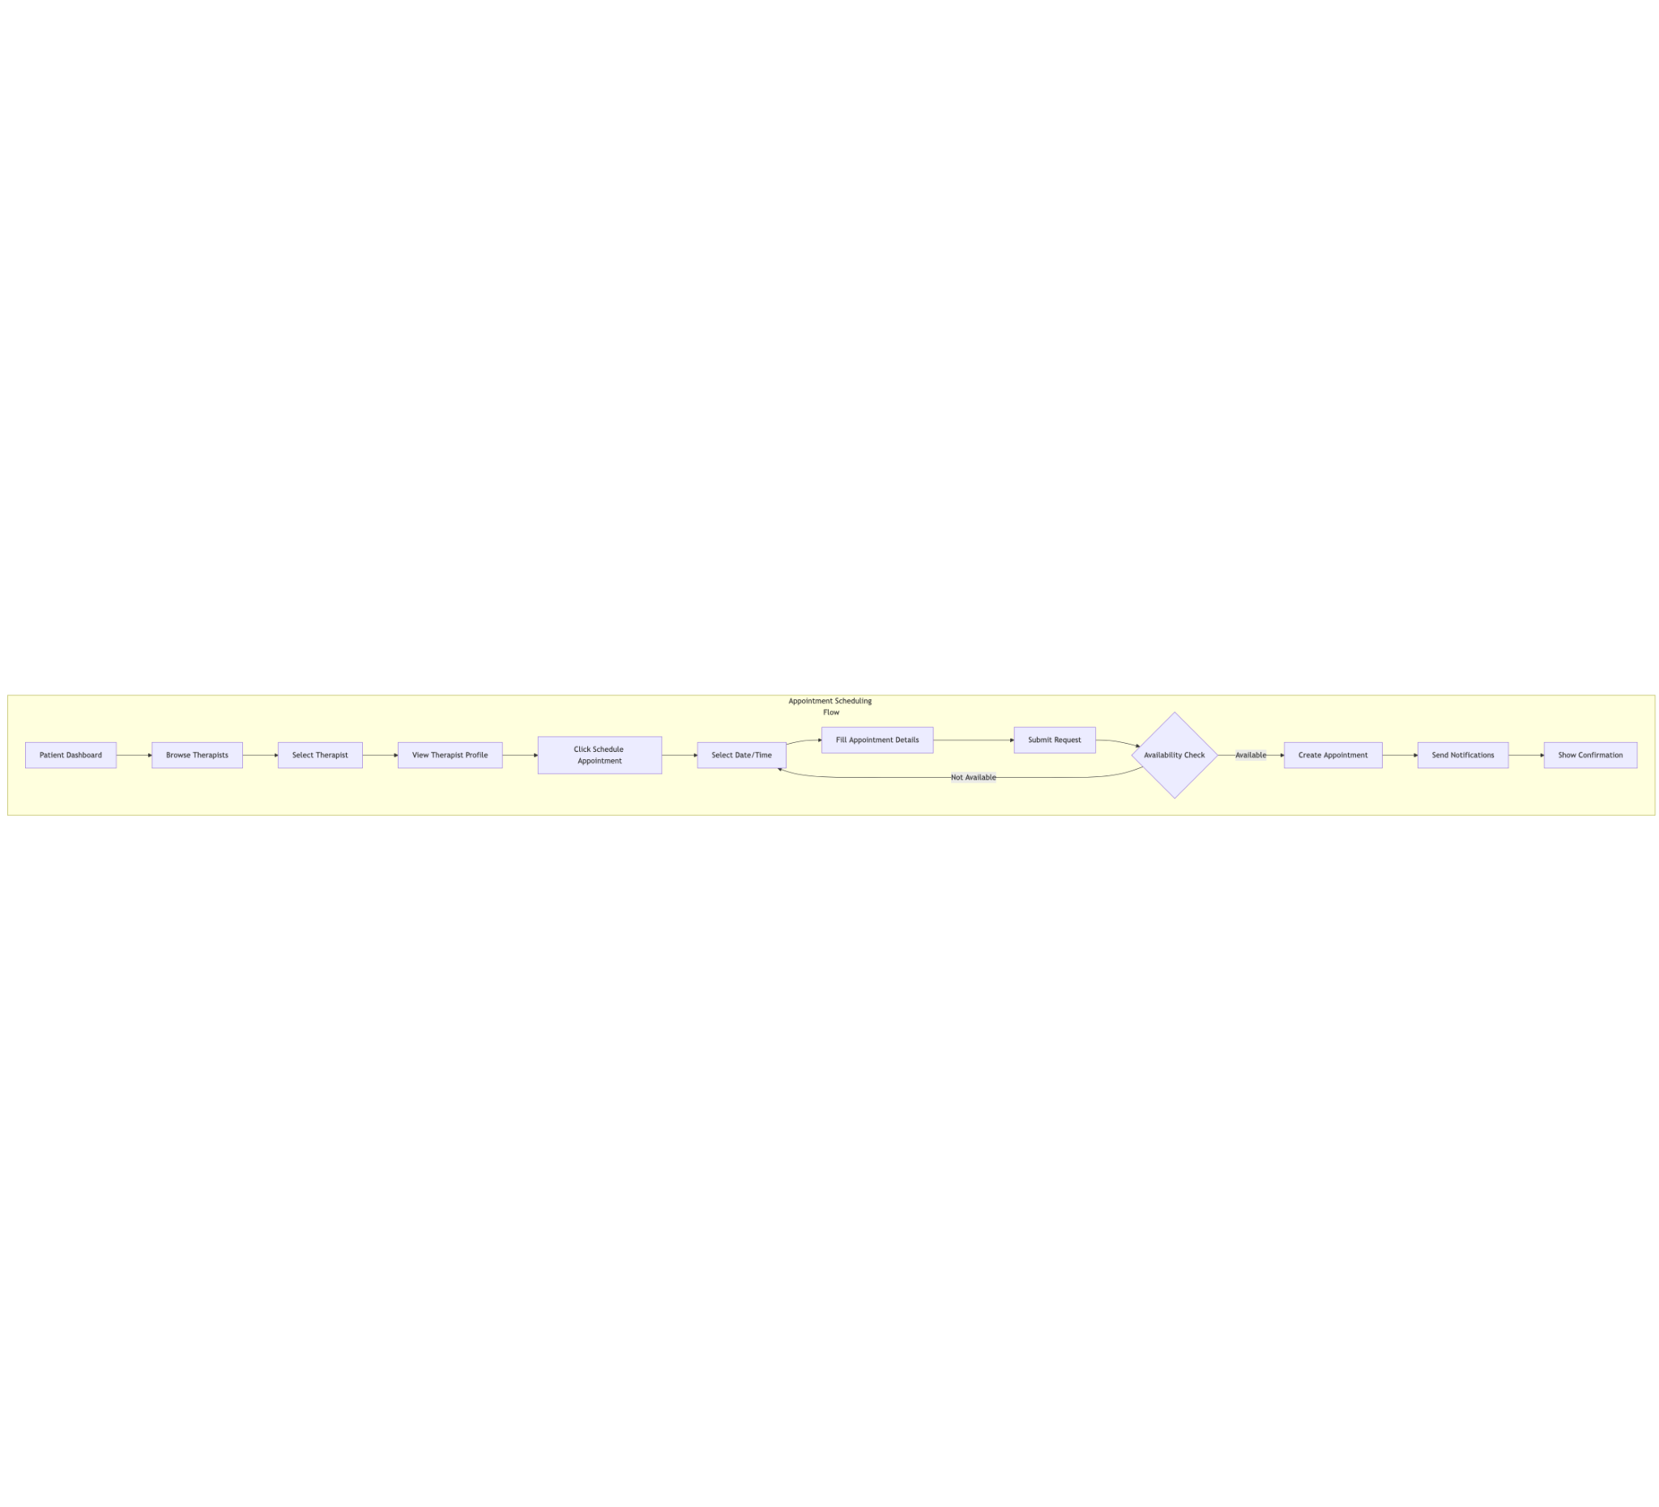
Figure 5: Appointment Scheduling Flow

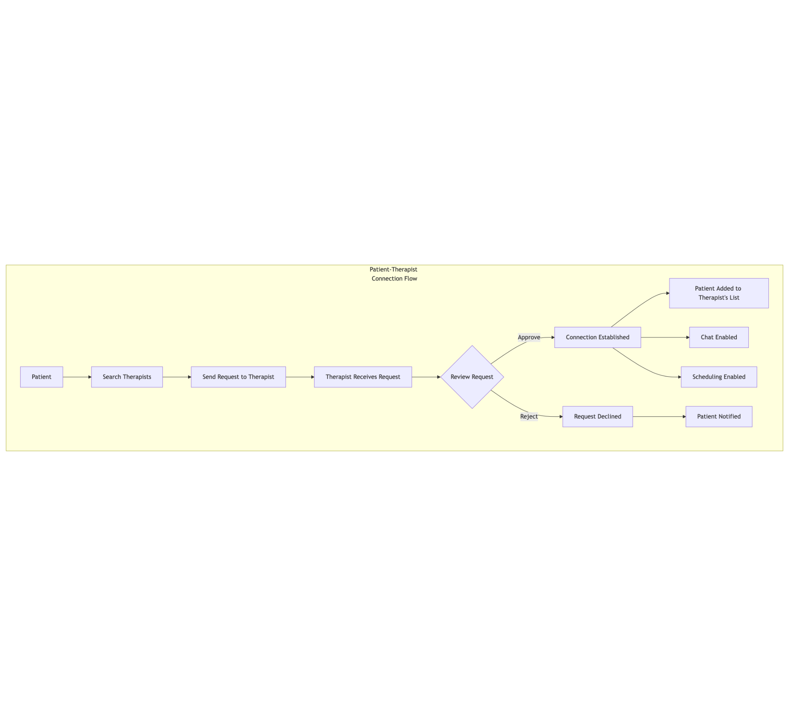
Figure 6: Patient-Therapist Connection Flow

4.9 Hardware Requirements
The system is designed to run efficiently on modern web browsers with the following minimal hardware requirements:

Server Requirements:

- CPU: Multi-core processor (4+ cores recommended)
- RAM: 8GB minimum, 16GB recommended
- Storage: 50GB SSD minimum
- Network: High-speed internet connection with low latency

Client Requirements:

- Any modern computer, tablet, or smartphone capable of running updated web browsers
- Minimum 4GB RAM for optimal performance
- Stable internet connection
- Audio/video capabilities for potential future telemedicine features

4.10 Software Requirements
Server Environment:

- Node.js 18.x or higher
- MongoDB 6.0 or higher
- npm or yarn package manager

Development Environment:

- Git for version control
- Code editor (VS Code recommended)
- MongoDB Compass for database management
- Postman for API testing

Client Environment:

- Modern web browsers (Chrome, Firefox, Safari, Edge)
- JavaScript enabled
- Cookies enabled for session management

Dependencies:

- Next.js 15.5.3
- React 19.1.0
- NextAuth.js 4.24.11
- Mongoose 8.18.1
- TailwindCSS 4.x
- Lucide React 0.544.0
- React Hot Toast 2.6.0

4.11 Documentation
The system is documented at multiple levels to facilitate maintenance, development, and usage:

- User Documentation:

  - Patient user guide
  - Therapist user guide
  - Admin system guide

- Technical Documentation:

  - API documentation with endpoint descriptions
  - Database schema documentation
  - Component documentation

- Code Documentation:

  - Inline code comments
  - TypeScript interfaces and type definitions
  - README files for major components

- Deployment Documentation:

  - Environment setup guidelines
  - Configuration options
  - Security best practices

All documentation is maintained alongside the codebase to ensure it remains current as the system evolves.

CHAPTER FIVE: SUMMARY, CONCLUSION AND RECOMMENDATION

5.1 Summary
The Mental Health Management System is a comprehensive web application designed to bridge the gap between mental health professionals and patients. The system provides a secure platform for scheduling appointments, exchanging messages, and managing the therapeutic relationship.

Key features implemented include:

- User authentication with role-based access control
- Therapist profile management with specializations and credentials
- Patient-therapist connection system with approval workflow
- Appointment scheduling with availability management
- Secure messaging between patients and therapists
- Resource library for mental health materials

The application is built using modern web technologies, with Next.js as the full-stack framework, React for the user interface, and MongoDB for data persistence. The architecture follows best practices for security, scalability, and maintainability.

5.2 Conclusion
The Mental Health Management System successfully addresses the need for digital tools in the mental healthcare space. By providing a user-friendly interface for both patients and therapists, the system streamlines administrative tasks, enhances communication, and ultimately improves access to mental healthcare services.

The implementation of the system demonstrates that technology can play a significant role in addressing challenges in healthcare delivery, particularly in areas like mental health where stigma and accessibility have traditionally been barriers to seeking help.

The modular design and modern technology stack ensure that the system can be maintained and extended as requirements evolve, making it a valuable tool for mental health practices seeking to digitize their operations.

5.3 Recommendation
Based on the development and initial implementation of the Mental Health Management System, the following recommendations are proposed for future enhancements:

- Telemedicine Integration: Implement video consultation capabilities to enable remote therapy sessions directly within the platform.

- Advanced Analytics: Develop analytics dashboards for therapists to track patient progress and practice metrics.

- Mobile Applications: Create native mobile applications for both iOS and Android to improve accessibility.

- Payment Processing: Integrate payment processing to handle session fees, insurance claims, and subscription models.

- AI-Assisted Features: Explore AI-driven features such as mood tracking, therapy suggestions, and automated appointment reminders.

- Expanded Resource Library: Enhance the resource library with interactive content, guided exercises, and personalized recommendations.

- Compliance Enhancements: Continue to strengthen security measures and ensure compliance with evolving healthcare regulations like HIPAA and GDPR.

- Community Features: Consider adding moderated community forums or group therapy capabilities for peer support.

These recommendations aim to build upon the solid foundation established by the current system, further improving mental healthcare delivery through technology.

